Electrode Potential and Cells

Introduction

Oxidation-Reduction reactions are an important class of chemical reactions.

*In Oxidation*: A species loses one or more electrons resulting in an increase in the oxidation number.

M🡪 Mn++ ne-

*In Reduction*: A species gains one or more electrons resulting in a decrease in the oxidation number.

A reduction process is always accompanied by an oxidation process since electrons can be lost by a species only when there is another species to receive them. Redox reactions form the basis of electrochemical cells. An electrochemical cell consists of two electrodes which when connected by a metallic wire produces electric current as a result of a spontaneous Redox reaction.

Each electrode usually consists of a metal in contact with a solution of its own ions. Since a cell is a combination if two electrodes, each electrode is referred to as a single electrode or a half cell. A potential called the electrode potential arises at the electrode in contact with its ionic solution. The difference between the potentials of the two half cells constitute an electromotive force (emf) of the cell.

Electrochemical cells

An electrochemical cell is a device in which chemical energy is converted into electrical energy or vice versa by a spontaneous Redox reaction. There are two types of electrochemical cells-

|  |  |
| --- | --- |
| **Galvanic cell** | **Electrolytic Cell** |
| Chemical energy is converted to electrical energy. | Electrical energy is converted to chemical energy. |
| Electrical current flows due to spontaneous Redox reaction. | Electrical energy is supplied to carry out a non spontaneous reaction. |
| The two electrodes are dissimilar | The electrodes may be similar or dissimilar. |
| Each metal is kept in contact with its own ionic solution | Only one electrolytic solution is required. |
| Salt bridge is used to transport ions to and from compartments | No salt bride is required as the cell has only one compartment |
| Anode is negative, Cathode is positive. | Anode is positive, Cathode is Negative. |
| Free energy change (G) is negative. | Free energy change is positive. |
| Example- Daniel cell | Example- Electrolytic refining of Aluminium. |

Daniel Cell



The Daniel cell consists of a zinc rod in contact with 1M solution of ZnSO4 and a copper rod in contact with 1M solution of CuSO4. The two rods are externally connected by a metallic wire with a voltmeter as shown. A salt bridge connects the solutions.

Once circuit is completed,

-Zinc rod dissolves in solution and the concentration of Zn2+ ions in ZnSO4 increases.

-CuSO4 solution becomes more dilute with Cu+2 ions and copper is deposited on Copper rod.

*At the Anode*: Zinc rod loses two electrons and forms Zn+2 ions- Zn(s) 🡪Zn+2(aq) +2e- {Oxidation}

*At the Cathode:* Cu+2 ion gains two electrons to form Cu-

Cu+2 (aq) +2e- 🡪 Cu(s) {Reduction}

Net cell reaction—

Zn(s) +Cu+2(aq) 🡪Zn+2(aq)+Cu(s) {Redox}

Thus a Daniel cell converts a spontaneous Redox reaction into electrical energy. The flow of electrons is from the Zinc electrode to the Copper electrode, the conventional current thus flows from the Copper electrode to Zinc electrode.

*Salt bridge-* A thin paste of Agar-Agar in water is added to boiling water containing a little of an electrolyte like KCl, it is drawn into an U tube and cooled.

- It connects the half cells internally and avoids the liquid junction potential. Thus polarisation of the electrodes is reduced and charges will not accumulate.

Sign Convention and Cell notations-

1. Anode is written on the left, cathode to the right.
2. Electrode on the left is written with the solid phase first and then the electrolyte, a vertical line or semicolon is used to separate the two. The electrolyte may be represented by the formula of the compound or the ionic species along with concentration in brackets. Ex-Zn|Zn+2
3. The cathode of the cell is written on the right side. The electrolyte is represented first and then the metal. A vertical line separates the two. Ex-Cu+2| Cu
4. Two vertical lines separating the two half cells indicate the salt bridge.
5. Flow of electrons from anode to cathode to be denoted and the emf of cell is written on the extreme right side.

Daniel cell may be represented as-

Zn|Zn+2||Cu+2|Cu E=+1.1V

🡪

Origin of electrode potential

Whenever a metal is in contact with a solution of its on ions, it has the tendency to lose (oxidation) or gain(reduction) electrons. Its observed potential is zero, as the rate of oxidation is equal to the rate of reduction. A state of equilibrium is attained.

When the metals are electrically connected to obtain an electrochemical cell, the rates of reactions are different. The driving force for the spontaneous electrode reactions arise as a result of the observed difference in the standard electrode potentials of the two dissimilar electrodes. As a result of this driving force, the electrons released due to oxidation at the anode are pushed through the external circuit to the cathode.

If the standard electrode potential of the two metals are different, the one with higher reduction potential induces the metal of lower reduction potential to oxidise and the electrode reaction proceeds in the forward direction only.

A metal of lower reduction potential generally undergoes oxidation giving its ions.

In such a case, when a metal electrode is in contact with an ionic solution, a potential is developed due to the interaction of the charged metal interface and the surrounding ions in solution.

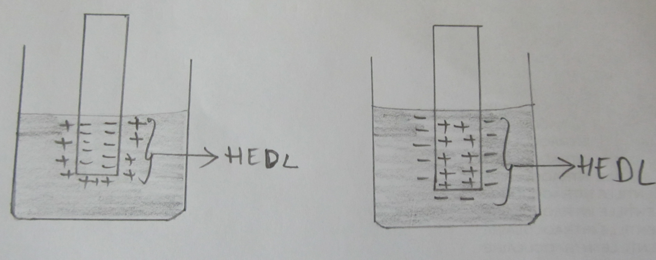

Simultaneously, at the other electrode of higher reduction potential, is the reduction of ions to metal at the metal interface. Therefore, a potential is developed due to the interaction of the charged metal interface and the surrounding ions in the solution.

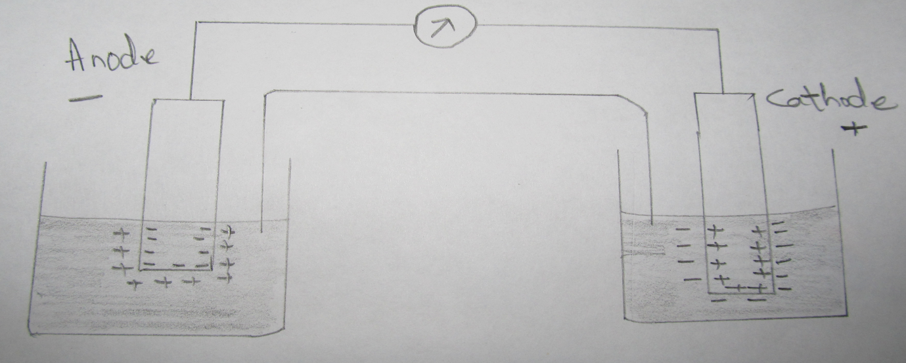

M1 and M2 are dissimilar metal electrodes in contact with its own ionic solution. The redox reaction takes place at the two half cells and a dynamic equilibrium is established between the positive/negative charges at the electrode interface.

-- Therefore due to interaction of the opposite charges at the respective electrodes, positive or negative ions remain close to the metal.

--This charged layer around an electrode is called Helmholtz Electrical Double Layer [HEDL].

--As a result, a potential exists between the interface of the metal electrode and its ionic solution at a particular temperature. This is called electrode potential.

-- Single electrode potential is defined as the potential established at the interface between M and M+ (ionic solution) when it is in contact with a solution of its own ions.

Single electrode potential depends upon-

1. Nature of the metal electrode
2. Concentration of metal ions in solution’
3. Temperature

**Nernst Equation**

A quantitative relationship between electrode potential and concentration of the substance is given by an expression known as Nernst equation.

In the reversible electrode reaction-

Mn+ + ne- 🡪M

The decrease in free energy represents the useful work that can be obtained from the chemical reaction. It is given by the thermodynamic equation-

-∆G= -∆ G0 – RT ln K

But, -∆G = nFE

Therefore: nFE = nFE0 – RT ln K

As Dissociation constant K = $\frac{[M]}{[Mn+]}$

nFE = nFE0 – RT ln

Dividing by nFE,

🡪E = E0 – ln

🡪E = E0 + ln

🡪E = E0 + ln [M+] [M] =1

🡪E = E0 + log [M+]

At 298K,

|  |
| --- |
| Ecell = E0 + log [Mn+]  Ecell = E0 + log  Ecell = E0 + log ] |

Where-

E = electrode potential

E0 = standard electrode potential

R = Universal Gas Constant [8.314J/K/mol]

T = temperature in Kelvin [298K]

F = Faraday [96500C]

n = number of electrons involved

This is the Nernst equation for the electrode potential.

Types of electrodes

1. *Metal –metal ion electrode-* A metal in contact with a solution of its own ions. Ex- Cu|Cu2+, Zn|Zn2+
2. *Metal insoluble salt electrode-* The metal is in contact with a solution containing the anion of the salt. Ex- calomel electrode, Ag|AgCl electrode
3. *Gas electrode-* The Gas is in contact with an inert meal dipped in the ionic solution of gas molecule. Ex-Standard Hydrogen Electrode.
4. *Oxidation reduction electrodes-* The electrode potential arises due to the presence of both oxidised and reduced species of some metal at an inert electrode(Pt). The developed potential could be due to the tendency of one form to change into another more stable form-potential is sensed by Pt. Ex- Pt|Fe2+;Fe3+ Pt|Sn2+;Sn4+
5. *Ion Selective electrode-* A membrane of a half cell is sensitive to a particular ion in a solution; ion exchange process takes place between the membrane electrode and the solution containing the specific ions and develops a potential which depends upon the concentration of that particular ionic species. Ex- glass electrode, solid state electrode, liquid membrane electrode.

Types of ion selective electrode-

--Glass membrane- pH electrode- this electrode exchanges H+ ions form an acid solution.

--Polymer membrane- PVC, polythenic or silicon rubber.

--Solid state- Utilises insoluble salts in a membrane. Ex-Silver|sulphide, chloride.

--Gas sensing electrode- gas permeable membrane.

Reference electrode- These are electrodes whose reduction potential is known to us and taken as standard to measure the reduction potential of the given electrode system.

Primary reference electrodes-

**Standard Hydrogen Electrode**

Hydrogen gas at a pressure of 1 atmosphere in equilibrium with 1M hydrochloric acid in the presence of platinum is called standard hydrogen electrode. Its potential is always taken as zero.

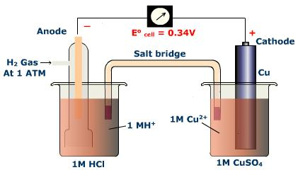

--The electrode whose potential is to be measured is coupled for potential measurement by a salt bridge.

--Zinc half cell is connected to the negative terminal and SHE to the positive terminal of the voltmeter. The emf of the cell is measure from the voltmeter.

🡪Ecell = Ecathode- Eanode

🡪0.76 V= ESHE –EZn

🡪0.76 V= 0 –EZn

🡪EZn =0.76V

Disadvantages of SHE-

🡪Difficult to maintain 1M Concentration of H+ ion

🡪Passing of hydrogen gas at 1atm pressure is difficult.

🡪Poisoning of Platinum catalyst by impurities.

Secondary reference electrodes-

Secondary reference electrodes are those whose potential with respect to SHE is known. They are commonly used to determine electrode potentials of other electrodes.

Examples- glass electrode, Ag|AgCl electrode, Calomel Electrode.

Calomel Electrode

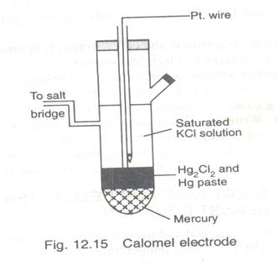

*Construction-*

1. The calomel electrode consists of a solid mercurous chloride in contact with mercury placed at the bottom of the long glass tube.
2. Mercurous chloride [Hg2Cl2] and mercury paste is placed over mercury; the remaining part of the tube is filled with KCl solution.
3. A platinum wire is dipped in mercury, it is used for external electrical contact.
4. The calomel electrode may act as anode or cathode depending on the nature of the other electrode.

*If it acts as anode-*

2Hg + 2Cl- 🡪 Hg2Cl2 + 2e-

*If it acts as cathode-*

Hg2Cl2 +2e- 🡪 2Hg +2Cl-

The potential developed from calomel electrode depends on the concentration of KCl solution.

For saturated KCl 🡪 0.241V

For 1N KCl 🡪 0.280V

For 0.1 N KCl 🡪 0.334V

The electrode is represented as-

Hg|Hg2Cl2|Cl-

*Applications-*

* Used as a reference electrode for the determination of pH
* It is used in potentiometric titrations.

E = E0 - log[Cl]2

E = E0 - 2 log[Cl]

At 298K

|  |
| --- |
| E = E0 – 0.0591 log [Cl-] |

Ag|AgCl electrode-

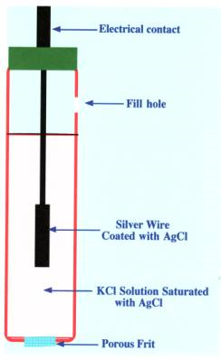

*Construction-*

1. A platinum wire is electrolytically coated with silver and then with silver chloride.
2. It is placed in KCl solution and its potential depends on the concentration of KCl solution.
3. Potential for saturated KCl 🡪 0.29V

0.1N KCl 🡪0.199V.

4) The platinum wire is used for external contacts and AgNO3 is added in drops to develop definite potential.

Cell representation-Ag|AgCl|Cl-

*At Anode:-* Ag(s) + Cl- 🡪 AgCl + e-

*At Cathode:-* AgCl(s) + e- 🡪 Ag(s) + Cl-

*Applications:-*

* It is used along with glass electrode to find the pH of a solution.
* It is non toxic compared to calomel electrode and inexpensive.
* It is stable and can detect voltages to 1mV

Ion selective electrodes- These electrodes have the ability to respond to specific ions and develop a potential in the mixture and ignoring the other ion.

Glass electrode

*Principle-*  When two solutions of different pH are separated by a thin glass membrane, the potential is developed and this potential is proportional to the pH value.

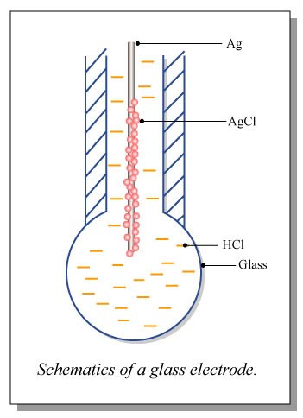

*Construction-*

1. It consists of a long glass tube with a thin glass membrane bulb at the bottom which is made up of a special type of corning glass.
2. The corning glass has low melting point and high electrical conductivity.
3. The bulb is filled with 0.1 m HCl and a platinum wire coated with Ag|AgCl is dipped in it. It is used for external contacts.
4. 1M HCl is taken in a beaker and the electrode is immersed inside it.

The cell is represented as-

Analyte | C2 = 0.1 M HCl | Ag|AgCl,Cl-

Solution[C1] | reference solution |

* Due to the difference in the concentration of ions and the pH a potential is developed at the membreane- [Ej] junction potential.

At equilibrium-

Na+(glass) + H+ (aq) 🡪 H+(glass) + Na+( aq)

By Nernst equation-

Ej = log

🡪Ej = log [C1] – log [C2]

At 298K ( 250C)-

🡪Ej = log[C1] - log[C2]

if [C2] is kept constant, 🡪 log[C2] = K

🡪Ej = log[C1] + K

Thus total potential- Eg = Ej + Ereference

🡪Eg = log[C1] + K + Ereference

If [K + Ereference]= E0g,

🡪Eg = E0g + log[C1]

As pH = -log [H+],

🡪Eg = E0g + log[H+] n=1 for H+

|  |
| --- |
| 🡪 Eg = E0g - 0.0591 pH |

Determination of pH using glass, calomel electrodes-

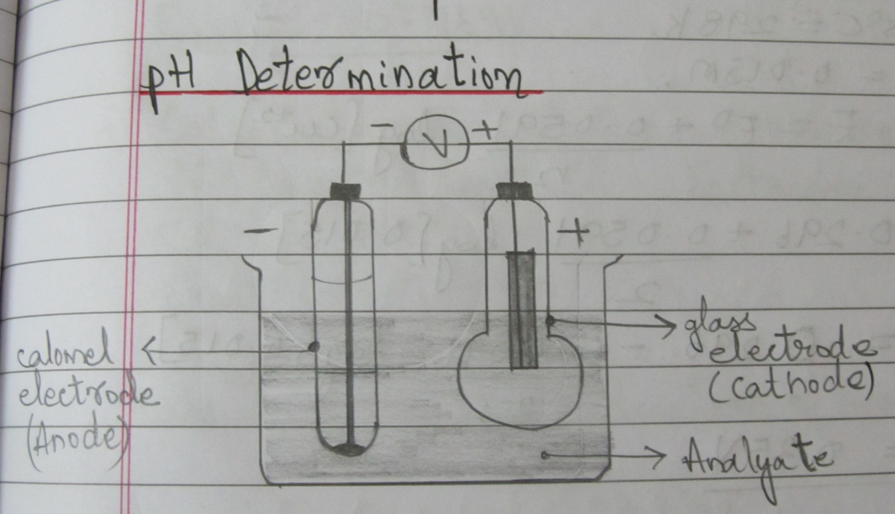

The glass electrode is coupled with the calomel electrode and dipped in the solution whose pH is to be determined. Calomel acts as anode and glass acts as cathode.

By general expression-

Ecell = Ecathode - Eanode

Ecell = Eg -Ecalomel

Ecell = E0g - 0.0591 pH- Ecalomel

Therefore-

|  |
| --- |
| pH = $\frac{ E0g - Ecell -Ecalomel}{0.0591}$ |

*Advantages of glass electrode-*

* It can be used in the presence of oxidising and reducing agents.
* It is not poisoned easily.
* It is simple to construct and is used in industries, agricultural labs, etc.

*Disadvantage*- It cannot be used for a solution whose pH is more than 9.

*Applications of ion selective electrodes-*

* It is used to find concentration of cations and anions
* To measure the level of CO2 in blood sample.

*Types of galvanic cells*

1. Primary cell- Electrochemical cells whose cell reactions are not reversible and thus cannot be recharged if completely discharged. Ex- Dry cell.
2. Secondary cells- Electrochemical cells whose cell reactions are reversible and thus can be recharged. Ex- Lead-acid storage cell, Ni-Cd cell etc.
3. Concentration cells

Concentration cells

It is an electrochemical cell in which both anode and cathode are made up of the same element in contact with same electrolytes but of varying concentrations.

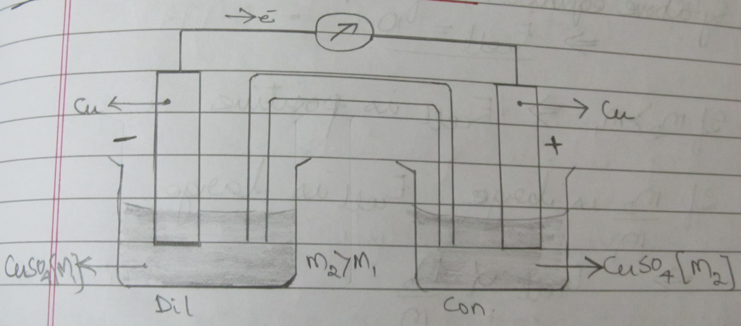

*Construction-*

Two copper electrodes are dipped in copper sulphate solution of different concentrations. The Cu electrode which is in contact with dilute solution acts as anode and that with concentrated solution acts as cathode.

The flow of electrons takes place from dilute solution to concentrated solution

*At Anode:-* Cu(s) 🡪 Cu+2(aq)[M1] + 2e-

*At Cathode:-* Cu+2(aq)[M2] + 2e- 🡪 Cu(s)

*Net cell reaction:-* Cu+2(aq)[M2]🡪 Cu+2(aq)[M1]

Concentration cell is represented as-

Cu(s) | Cu+2[M1]|| Cu+2 [M2] |Cu(s)

Ecell = Ecathode - Eanode by Nernst equation-

🡪 Eanode = E0 + log[M2]

🡪 Ecathode = E0 + log[M1]

Ecell = E0 + log[M2] - E0 - log[M1]

Therefore-

|  |
| --- |
| Ecell = log $\frac{[M1]}{[M2]}$ |

By the above equation-

🡪If [M1] = [M2] – emf of the cell is zero

Ecell =

🡪If [M2]> [M1] – emf is positive

🡪If $\frac{[M1]}{[M2]}$ is large, - Ecell is large.

Significant theory questions-

1. What is single electrode potential? Derive Nernst equation for single electrode potential.
2. Discuss the origin of electrode potential.
3. What are concentration cells? Deduce the expression for the EMF of copper concentration cell.
4. Explain the construction of Ag|AgCl electrode. Give half cell and net cell reactions.
5. Write a short note on calomel electrode.
6. What are ion selective electrodes? Explain its principle and working.
7. Write a short note on calomel electrode.
8. Explain how glass electrode can be used to determine the pH of a solution.

**Remember these equations to solve problems-**

1. -∆G = nFE
2. Ecell = Ecathode - Eanode
3. Ecell = E0 + log [Mn+]
4. Ecell = E0 + log
5. Ecell = E0 + log

🡪🡪An Academic initiative by

* Chiraag Kashyap

NHCE “A” EEE