ELECTRODE POTENTIAL AND CELLS:

INTRODUCTION: Important class of chemical reactions is oxidation-reduction reactions.

In oxidation: a species loses one or more electrons resulting in an increase in its oxidation number.
M M^{n+} + ne⁻

In reduction: the species gains one or more electrons, there is a decrease in oxidation number.

M^{n+} + ne⁻ M

A reduction process necessarily accompanies an oxidation process since electrons can be lost by a species only when there is a counterpart to receive them. Redox reaction forms the basis of electrochemical cells. An electrochemical cell consists of two electrodes which when connected by a metallic wire: an electric current flows as a result of a spontaneous redox reaction.

Each electrode usually consists of a metal in contact with a solution of its own ion. Since a cell is a combination of two electrodes, each electrode is referred to as a single electrode or half- cell. A potential called the electrode potential arises at the electrode in contact with its ionic solution. The difference between the potentials of the two half- cells constitutes the electromotive force (emf) of the cell.

Emf: “The voltage under the influence of which the electric current flows in the cell is called the electromotive force of the cell or the emf of the cell”

ELECTROCHEMICAL CELLS: Definition: Electrochemical cell is a device in which chemical energy is converted into electrical energy or electrical energy into chemical energy by oxidation-reduction reaction. Thus, there can be two types of Electrochemical cells.
1.Galvanic cell or voltaic cell: the one, which converts chemical energy into electrical energy.
2.Electrolytic cell: the one, which converts electrical energy into chemical energy.

GALVANIC CELL:

A typical egs of galvanic cell is Daniel cell, which is illustrated in the fig.
CONSTRUCTION AND WORKING: It consists of two beakers one of which contains zinc rod immersed in zinc sulphate solution and the other one contains copper rod in copper sulphate solution. A salt bridge connects the solutions of two beakers. The zinc and copper rods are connected externally through voltmeter by using a wire. On completing the circuit the following changes are observed
1.zinc rod starts dissolve
2.copper gets deposited on copper rod
3.zinc sulphate solution becomes more concentrated with respect to Zn²⁺ ions
4.copper sulphate solution becomes more dilute with respect to Cu²⁺
5.Migration of ions takes place in solution.

The above observations are explained by the following oxidation-reduction reactions taking place at anode and cathode respectively.

At the anode: Zn Zn²⁺ + 2e⁻ oxidation half- cell

At the cathode: Cu²⁺ +2e⁻ Cu reduction half- cell

Net reaction Zn + Cu²⁺ Zn²⁺ + Cu cell reaction

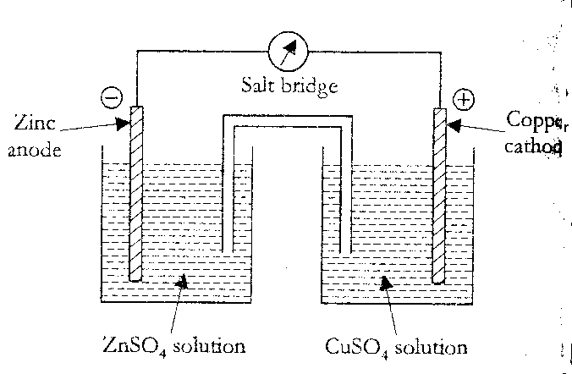 By convention, the electrode at which oxidation occurs is anode and the electrode where reduction occurs is cathode. In a galvanic cell anode is negative and cathode is positive. The flow of electrons is from zinc electrode to copper electrode. Hence the flow of conventional current is from copper electrode to zinc electrode.
The net redox reaction, called electrochemical reaction, is the cause for production of electricity. The net reaction is the sum of two electrode reactions and is called cell reaction. Each electrode reaction is called as half-cell reaction.

SALT BRIDGE: It is easy to construct. A thin paste of agar-agar in water is added to boiling water containing a little of an electrolyte like KCl or KNO_{3.} It is then drawn preferably into U- tube and cooled.
FUNCTION: The salt bridge not only connects the two half-cells internally but also avoids the liquid junction potential. With this, the polarization of the electrodes is considerably reduced. In other words, it prevents the accumulation of charges around the electrodes.
NOTE: 1. When one of the solutions contains soluble silver, mercurous or thallous salt, the KCl salt bridge cannot be employed.
2.KCl or KNO₃ is used because the ions have almost same migration velocities.
CELL NOTATION AND CONVENTIONS: The conventions employed in the representation of electrochemical cell are as follows.

- Anode is written on the left hand side, while cathode is written on the right hand side.
- The electrode on the left (i.e. anode) is written by writing the metal or solid phase first and then the electrolyte. A vertical line or a semicolon separates the two. The electrolyte may be represented by the formula of the whole compound or by ionic species. Additional information regarding concentration may also be mentioned in bracket. Egs: Zn/ Zn²⁺ or Zn: ZnSO₄ (1M); Pt, H2 (1atm), H+(1M)

- The cathode of the cell (at which reduction takes place) is written on the right hand side. In this case, the electrolyte is represented first and the metal there after. A vertical line or a semicolon separates the two.
- Egs: Cu²⁺ / Cu or Cu²⁺; Cu or Cu²⁺ (1M); Cu or CuSO4; Cu

- Two vertical lines separating the two half- cells indicate a salt bridge. Thus applying the above considerations to Daniel cell, we may represent it as

Zn; Zn²⁺(1M) // Cu²⁺; Cu
SINGLE ELECTRODE POTENTIAL: When a metal is in contact with a solution of its own ions, the two possible reactions that take place are:

The metal ion goes into solution leaving the electrons to accumulate in the metal, as a result the metal being negatively charged with respect to the solution.

M M^{n+} + ne⁻

Since electrons of a metal are utilized by another metal ion depositing on it, the former is positively charged with respect to the solution.

M^{n+} + ne⁻ M

If the ionization reaction is faster than the deposition reaction, the metal acquires a net negative charge, and retards the rate at which the positive ions leave the metal and increase the rate at which the positive ions reach the electrode surface. When the two rates are equal equilibrium is established. If the deposition reaction is faster, the metal acquires a net positive charge, resulting in the acceleration of the ionization reaction and retardation of the deposition reaction. This leads to the establishment of equilibrium. As a result of the buildup of charges on the metal, an electrical double layer is established at the metal solution interface. The resultant potential difference between the metal and the solution is called the electrode potential.

NERNST EQUATION: A quantitative relationship between electrode potential and concentration of the substance involved. This expression is known as Nernst equation.

Consider the following reversible electrode reaction

M^{n+} + ne⁻ M (1)

The decrease in free energy represents the maximum amount of work that can be obtained from a chemical reaction.
_ G = W_{max} (2)

The work performed by an electrochemical cell depends on 1. Number of coulombs that flow and the energy available per coulomb.

Energy available
Work = number of coulombs *
Coulomb
The number of coulombs that flow is equal to the product of number of moles of electrons (n) that are involved in the cell reaction and the faraday (F).

Number of coulombs = nF

Energy available per coulomb is the emf of the cell E, since volt is equal to energy per coulomb. When the emf is maximum the work derived from the cell is also maximum. The maximum emf is the cell potential E_{cell.}

Thus Wmax = n * F * E (3)

Equating (2) and (3)

ΔG = - nFE (4)

Under standard conditions equation (4) can be written as
ΔG⁰ = - nFEº (5)

The free energy change for spontaneous reaction is related to equilibrium constant K_{c}, by the expression Δ G = ΔG⁰ + RTlnK_{c}
[product]
₌ Δ Gº + RTln ___________
[reactant]

[M]
= Δ Gº + RTln
[M^{n+}]
Substituting –nFE for Δ G and -nFEº for Δ Gº gives
[M]
-nFE = -nFEº + RTln ⁽⁶⁾
[M^{n+}]

Dividing throughout by –nf, the expression (6) becomes
RT [M]
E = Eº - __ ln ______
nF [M^{n+}]

SINCE [M] = 1
RT 1
E = Eº - __ ln ______
nF [M^{n+}]

2.303 RT
E = Eº + __ ln [M^{n+}] at 298K (7)
nF

WHERE E= electrode potential
Eº = standard electrode potential
R= gas constant 8.314J/K/mol
T= temperature in Kelvin unit 298k
F= Faraday 96,500C
n = number of electrons involved
The equation (7) is called nernst equation and can be used to calculate electrode potential. It may be seen from the equation (7) that the electrode potential, for the reaction
M^{n+} M-ne⁻ , increase with the increase in concentration of M^{n+} and temperature.
Nernst equation can also be applied for calculation of emf of a cell.
Consider the following cell reaction
Zn + Cu²⁺ Zn²⁺ + Cu
Emf of the cell is given by the nernst equation as
2.303RT [Zn²⁺]
E_{cell}= Eº_{cell} - log
2F [Cu²⁺]

similarly if the reaction is mA + nb xc + yD
0.05692 [C]^{x}[D]^{y}
E_{cell}= Eº_{cell} - log
n [A]^{m}[B]^{n}

STANDARD ELECTRODE POTENTIAL [Eº]
We know that Nernst equation
0.0592
E = Eº + n log [M^{n+}]

When [M^{n+}] = 1, E =Eº
Thus the electrode potential is defined as the potential developed on the electrode at the interface when it is in contact with a solution of its own ions at equilibrium, at unit ionic concentration and 298K.If the electrode involves a gas, then the gas is at one atmospheric pressure.
The magnitude of the standard electrode potential is a measure of its tendency to undergo reduction, when two electrodes are coupled to form a cell, the one with lower Eº value acts as cathode.

CALCULATION OF STANDARD EMF OF A CELL:

The standard emf of the cell is calculated using the following expression

Eº_{cell} = Eº_{cathode} - Eº_{anode}

= Eº_{R} - Eº_{L}
Eº_{cell} = Eº_{Rduction} - Eº_{oxidation}

MEASURMENT OF ELECTRODE POTENTIAL: It is impossible to know the absolute value of a single electrode potential. We can only determine the relative value of electrode potential if we can fix arbitrarily the potential of one electrode. For this purpose the potential of SHE has been arbitrarily fixed as zero. This electrode is represented as Pt, H₂ (1atm); H⁺(1M)
Whenever, the potential of any electrode say M / M^{n+} is to be measured experimentally, it is combined with the standard hydrogen electrode as given in the following cell
M / M^{n+} // H⁺(1M) / H₂ (1atm); Pt
The emf of the above cell is measured by the electronic voltmeter and the measured emf will be equal to the required potential of the electrode on the hydrogen scale, by taking potential of the hydrogen electrode as zero.
For eg: To measure the potential of zinc electrode, the zinc electrode is coupled with SHE through a salt bridge to get the following cell assembly
Zn / Zn²⁺(aq) // HCl, [H+]=1M / H₂ (1atm); Pt
The potential of the cell assembly is found to be 0.76V.
Eº_{cell} = Eº_{Rduction} - Eº_{oxidation}

=Eº_{SHE} - Eº _{Zn2+/ Zn}
0.76V= 0 - Eº _{Zn2+/ Zn}
Eº _{Zn2+/ Zn} = - 0.76V

TYPES OF CELLS: 1. CHEMICAL CELL
2. CONCENTRATION CELL
CHEMICAL CELL: These are the cells in which the emf is due to a chemical reaction- taking place within the cell.
CONCENTRATION CELL: A cell in which electrical energy is produced by the transference of a substance from a system of high concentration to one at low concentration is known as a concentration cell.
A concentration cell is made up of two half-cells having identical electrolyte, electrodes except that the concentration of the reactive ions at the two electrodes are different. The two half-cells are joined by salt bridge eg.
Ag / AgNO₃ (C₁) / salt bridge of saturated NH₄NO₃ / AgNO₃ (C₂) / Ag
Dilute concentrated

Ag / AgNO₃ (C₁) // AgNO₃ (C₂) / Ag [C₂ > C₁]

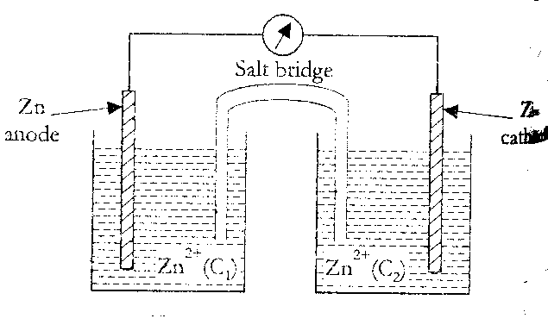
When a metal (M) electrode is dipped in a solution containing its own ions [M^{n+}], then a potential (E) is developed at the electrode, the value of which varies with the concentration of the ions in accordance with the Nernst equation.

2.303RT
E_{cell}= Eº_{cell} + log C
nF

Let us consider a general concentration cell represented as
- +
M / M^{n+} (C₁M) // M^{n+}(C₂M) /M C₂ >C₁
THEREFORE emf of the cell = E_{R} - E_{L}
0.0592 0.0592
=[Eo + n log C₂] – [Eo + n logC₁ ]
0.0592 C₂
Ecell = n log C₁

- When C₂ = C₁, the concentration cell does not generate electrical energy.
- Higher the ratio of C₂/ C₁, greater is the cell potential.

TYPES OF ELECTRODES:

METAL-METAL ION ELECTRODE: This type of electrode consists of a metal in contact with a solution of its own ions.

Egs: 1Zinc in a solution of zinc sulphate.
2.Copper in a solution of copper sulphate.

METAL-METAL SALT ION ELECTRODE: This type of electrode consists of a metal in contact with one of its sparingly soluble salts and a solution of a soluble salt having a common anion with the sparingly soluble salt.

Egs: 1. Calomel electrode Hg / Hg₂Cl₂ / Cl⁻
- Silver-Silver chloride electrode Ag / AgCl (s) / Cl⁻

GAS ELECTRODE: A gas electrode consists of a particular gas flushed around an inert electrode (Pt), which is dipped in a solution containing ions to which it is reversible.

Egs: SHE Pt / H₂ (1atm) / H⁺ (1M)

OXIDATION-REDUCTION ELECTRODE: This type of electrode consists of an inert electrode (Pt 0r Au) immersed in a mixed solution containing both the oxidized and reduced forms of a molecule or ion.

Egs: Pt / Fe²⁺: Fe³⁺

Pt / Sn²⁺: Sn⁴⁺

REFERENCE ELECTRODE:

Reference electrodes are those whose potentials are known.

PRIMARY REFERENCE ELECTRODE [SHE]: Hydrogen gas at a pressure of one atmosphere in equilibrium with one molar hydrochloric acid in the presence of platinum is called standard hydrogen electrode.

CONSTRUCTION OF NORMAL HYDROGEN ELECTRODE [NHE OR SHE]:

It consists of a rectangular piece of platinum foil, which is covered with finally divided Pt black, which adsorbs large quantity of hydrogen and so acts as hydrogen electrode. The electrode is immersed in a solution of HCl containing hydrogen ions at unit activity. Pure hydrogen gas is bubbled at one atmospheric pressure. The temperature is maintained at 298K. By convention the potential of such electrode has been taken as zero. This electrode is represented as
Pt, H₂ (1atm); H⁺(1M)
Working: At anode ½ H₂ H⁺ + e⁻ FIG.
At cathode H⁺ + e⁻ → ½ H₂

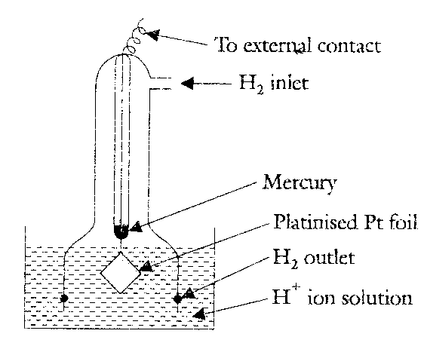

LIMITATIONS OF HYDROGEN ELECTRODE:
- It is difficult to maintain the pressure of hydrogen gas uniformly at one atmosphere.
- It is difficult to maintain the hydrogen ion concentration 1M throughout the experiment.
- Platinum foil is easily poisoned by the adsorption of impurities present in the solution.
- The adsorptions of impurities on the platinum foil decrease the adsorption of hydrogen and hence equilibrium between hydrogen gas and hydrogen ions gets disturbed.
- Hydrogen electrode cannot be used in the presence of oxidizing agent.
These limitations lead to the construction of secondary reference electrode.

SECONDARY REFERENCE ELECTRODE: 1.Calomel electrode 2. Ag-AgCl electrode 3. Ion-selective electrode.

CALOMEL ELECTRODE: The calomel electrode consists of a glass vessel containing a layer of Hg over which is placed a paste of an Hg, Hg₂Cl₂ and KCl. Above this there is a solution of KCl saturated with the Mercurous salt. A platinum wire is fused in the glass tube for electrical connection. A salt bridge is used to couple with other half-cell.

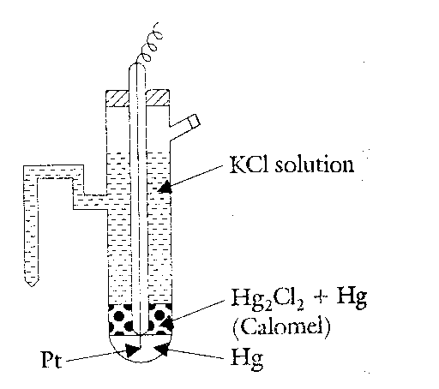

The half-cell is represented as

KCl (sat), Hg₂Cl₂ (sat), Hg

The half-cell reaction is
1/2 Hg₂Cl₂ (s) + e⁻ Hg + Cl⁻

The potential of the calomel electrode depends on the concentration of KCl used. For saturated KCl, the potential is +0.241V, FOR 1M and 0.1M KCl the values are 0.280V and +0.334V respectively.

USES: The calomel electrode is simple to construct, the cell potential is reproducible and stable over a long period and does not vary with temperature. Hence it is commonly used as a secondary reference electrode for potential measurements.

SILVER-SILVER CHLORIDE ELECTRODE: It is a secondary reference electrode used in analytical instrumentation.
It is prepared by coating a thin layer of AgCl electrolytically on a silver wire. The wire when placed in a solution of KCl with 1 0r 2 drops of 1M silver nitrate develops a definite potential depending on the concentration of the electrolyte used.

The electrode can be represented as Ag / AgCl (s)/Cl⁻

The half-cell reaction is AgCl + e⁻ Ag + Cl⁻
The electrode potential at 298K of saturated KCl, 1N KCl and 0.1NKCl electrodes are 0.290V and 0.199V respectively.

APPLICATION:

- As a secondary reference electrode in place of calomel electrode / glass electrode / ion selective electrodes.
- In determining whether the potential distribution is uniform or not in ship hulls and old pipelines protected by cathodic protection.
- As a portable reference electrode for measuring the different depths of oil rigs and platforms, submerged oil pipelines etc. usually such probe is powered by Ni – Cd battery and can operate up to a depth of 300-400m with precision of ±1mv.

Ion-selective electrode: Possesses the ability to respond only to certain specific ions, thereby developing potential w.r.t that species only in a mixture and ignoring the other ions totally. In other words, the potential developed by an ion-selective electrode depends only on the concentration of species or ions of interest. For egs. Glass membrane is only H⁺ ions selective.
The material employed for some ion-selective membranes are mentioned below

SOLID STATE MEMBRANE: 1. For fluoride ions lanthanum trifluoride crystal doped with europium diflouride is used.
2.For chloride ions: pressed pellet of Ag₂S + AgCl. The electrode has a Teflon body and the pellet is held in position by using epoxy resin.

LIQUID STATE MEMBRANE: 1. For certain alkali and alkaline earth cations neutral monocyclic crown ethers and phosphate diester is used.
2. For anions iron Phenonthrolic complexes are used. Liquid state membrane is usually obtained by adsorbing the active molecules on an inert porous support such as porous polymer.

DETERMINATION OF CONCENTRATION OF A METAL ION:

A schematic set up for determining the concentration of metal ions of interest in a solution by using ion-selective electrode is

Ion selective membrane

Reference solution to be Internal standard Identical reference
electrode analyzed solution electrode
[M^{n+}] = C₁ =? [M^{n+}] = C₂

Potential is given by

E_{cell} = RT/nF log C₂/ C₁

= RT/nF log C₂ - RT/nF log C₁

= Constant – RT/nF log C₁
WHERE C₁= C
E_{cell} = Constant – 0.0592/n log C
{This equation is valid if the membrane employed is selective only to the ions to be analyzed. However, the concentrations of the other ions present in system/mixture also have some effect on the value of membrane potential consequently the above equation is modified to

E_{cell} = Constant – 0.0592/n log [C + Σ K_{i} C_{i} ]

Where C_{i} = Concentration of the other ions present in the system/mixture and
K_{i} = Selectivity co-efficient of the ions. }

LIMITATIONS:

1.Usually, ion- selective membranes can be used in solution of P^{H} value up to 10, since higher P^{H} value affects these.
2.Although, ion-selective membranes are very thin, yet their resistances are extremely high (of the order million ohms), so it is necessary to use electronic potentiometers to measure the potential difference.

APPLICATION: In the determination of (1) concentration of cations egs. H⁺ , Li⁺, Na⁺, K⁺, NH⁴⁺, Ag⁺, Pb²⁺, Cd²⁺, hardness (Ca²⁺, Mg²⁺) and anions egs. Halide ions, NO^{3-,} CN^{-,} S²⁻ etc.
- P^{H} of a solution by using H⁺ ion-selective glass electrode.3. The concentration of glass using gas- sensing electrodes. For egs. Glass electrode is kept in contact with a very thin walled carbon dioxide permeable silicone rubber membrane soaked in dilute NaHCO₃ solution, then the electrode is dipped in the blood sample under test. Since the membrane is permeable to carbon dioxide, so carbon dioxide permeates into the membrane, thereby causing reaction between NaHCO3 and CO₂, eventually, the P^{H} value is altered, which is sensed by the glass electrode.

Thus the potential of the glass electrode gives a measure of the carbon dioxide in the blood sample.

GLASS ELECTRODE:

PRINCIPLE: If solutions of different P^{H} are separated by a thin glass membrane, a potential is developed across the glass membrane whose magnitude depends on the difference in P^{H} of the two solutions if P^{H} of one of these is held constant, the observed glass electrode potential is a linear function of P^{H} of the second solution.

E_{G} = E_{G}º – 0.0591 P^{H}

Where E_{G} is the potential of the electrode and E_{G}º is a constant for the given electrode depending upon the nature of the glass.
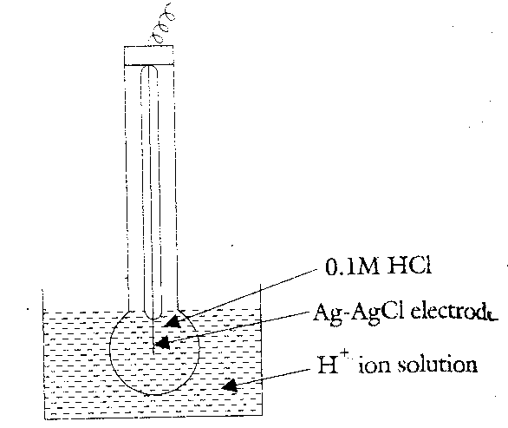
CONSTRUCTION: A glass electrode consists of a long glass tube with a thin walled bulb at one end, special glass of low melting point and high electrical conductance is used for the purpose [corning glass 22% Na₂O, 6% CaO and 72% SiO₂]. The bulb is filled with 0.1M HCl.
FIG.
A silver-silver chloride electrode dipped in the solution provides an electrical contact. The bulb of the glass electrode is dipped into any solution containing hydrogen ions. If the hydrogen ion concentrations of the solution inside and outside the glass membrane are different then the potential develops across the glass membrane. Glass electrode can be represented as Ag / AgCl (s) / 0.1M HCl / glass

ADVANTAGES:

- It is simple to operate.
- It is not poisoned easily.
- It can be used both in oxidizing and reducing agents.
- The equilibrium between the two solutions is reached quickly.
- Only a few drops of the liquid are enough to determine the P^{H}.
- It provides accurate results.
- It can be used in solution with P^{H} values ranging from 0 to 10.

DISADVANTAGES:

- Glass electrode cannot be used in presence of fluoride ions.
- It cannot be employed in pure ethyl alcohol, acetic acid and gelatin.
- The bulb is too fragile, so the glass electrode has to be used with utmost care.
- Glass electrode cannot be used when P^{H} of the solution is above 10, as it introduces alkaline error.

DETERMINATION OF A P^{H} OF A SOLUTION USING A GLASS ELECTRODE:

Glass membrane is found to be sensitive to hydrogen ion of an acidic solution. The membrane undergoes ion-exchange reaction; the Na⁺ ions of glass are exchanged for H⁺ ions.

H⁺ + Na⁺Cl⁻ Na⁺ + HCl

When a thin walled glass bulb containing N/10 acid, HCl solution is immersed in an acidic solution of different concentration [C₁> C₂] a boundary potential, E_{b} is developed across gel layers of the glass membrane. This potential E_{b} arises due to the difference in the H+ ion concentration inside and outside the glass bulb i.e.

E_{b} = E₁ – E₂
Thus E_{b} = E₁ – E₂ = 2.303RT/nF log C₁/ C₂

E_{b} = 2.303RT/nF log C₁ - 2.303RT/nF log C₂

= Constant + 2.303RT/nF log C₁

Where C₁ is the concentration of H⁺ ions of the solution into which the glass membrane is immersed.

The concentration of H⁺ ions (C₂) inside the bulb is constant.

Therefore E_{b} = Constant + 0.0591/n log C₁

E_{b} = Constant + 0.0591/n log [H⁺]

E_{b} = Constant – 0.0591/1 P^{H}

E_{b} = Constant – 0.0591 P^{H}

When the glass electrode is immersed in another acidic solution the potential of the glass electrode, E_{G} is given by

E_{G} = E_{b} + E_{Ag/}AgCl

In addition to this a small asymmetric potential contribution exists even if C₁ = C₂

E_{G} = E_{b} + E_{Ag/}AgCl + E_{asymmetric}

E_{G} = [Constant – 0.0591 P^{H}] + E_{Ag/}AgCl + E_{asymmetric}

The potential of the glass electrode is given by

E_{G} = E_{G}º – 0.0591P^{H}

Where E_{G}º = K + E_{Ag/}AgCl + E_{asymmetric}, is constant for a particular material.

In order to determine the P^{H} of a solution a glass electrode is coupled with a saturated calomel electrode (SCE).

The cell is represented as
Hg / Hg₂Cl₂ / Cl⁻ // unknown solution / glass electrode

SCE and glass electrodes are connected to electronic potentiometers to determine the emf of the cell. Knowing the E_{G}º of the glass and potential of the saturated calomel electrode, the P^{H} of unknown solution is calculated, thus

E_{cell} = E_{cathode} - E_{anode}
= E_{G} - E_{SCE}
= E_{G}º – 0.0591 P^{H} - E_{SCE}

E_{G}º - E_{cell} - E_{SCE}
P^{H} = 0.0591

